Kentucky Mtn Diamond Dawson Pedigree and Info
Tracey’s Moonlight BJ
NITECH CH ‘PR’ Moonlight Trailer
GRCH ‘PR’ Tracey’s Moonlight Penny
GRCH ‘PR’ Moonlight Drummer
‘PR’ Acheson & Burnworth’s Bang
CH ‘PR’ Sadis Slammin Coon
Wooded Swamp Red
CH ‘PR’ Moonlight Charlie
GRNITECH GRCH ‘PR’ Wilcox’ Thunder Bingo
NITECH ‘PR’ Oney’s King
‘PR’ Jack’s Thunder Sue
‘PR’ Spieth’s Big Time Kate
NITECH ‘PR’ Perk’s Northern Cujo
‘PR’ Oney’s Kate
‘PR’ Weddle’s Judy
SIRE: CCH GRCH ‘PR’ Kentucky Mtn. Moonlight Diamond DNA-P
GRNITECH Smith’s Hardtime Rocky
GRCH GRNITECH ‘PR’ Oliver’s Hard Time Moses
‘PR’ Gladyfork Squalling Sue
NITECH CH ‘PR’ Hard Time Chance
GRNITECH ‘PR’ Powers’ Hardtime Red Cloud
‘PR’ Power Rock Space Jam
NITECH ‘PR’ Power’s Redsky Kayla
GRCH ‘PR’ Clown Around Patches
GRNITECH GRCH ‘PR’ Sugar Creek J.R.
NITECH Cron’s Bran Bottom Tag
CH Di Bar’s Hardtime Dusty
‘PR’ Johnson’s Lady Rockin Clown
GRNITECH Smith’s Hardtime Rocky
NITECH GRCH ‘PR’ Hardtrockn Clown CH ‘PR’ Koly’s Little Lady

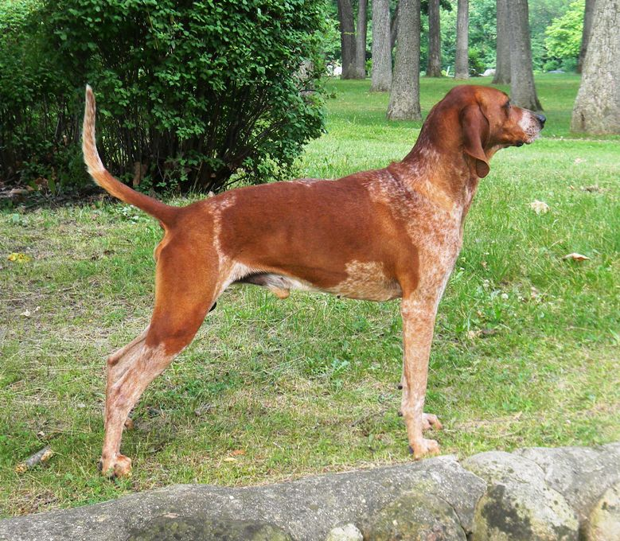

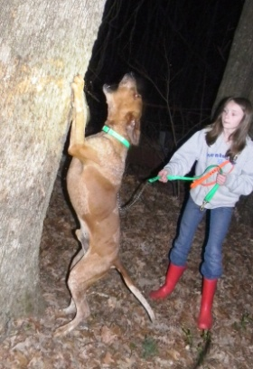

GRNITECH GRCH ‘PR’ Wilcox’ Thunder Bingo
GRNITECH GRCH ‘PR’ Wilcox Thunder Ringo
GRCH GRNITECH Ash’s Sundown Sally
GRNITECH GRCH Thompson’s Frankenstein
GRNITECH Briar Creek Bush Hog
GRNITECH CH ‘PR’ Rock Run’s Northridge Zee Zee
GRNITECH Northridge Willy’s Jojo
GRNITECH GRCH ‘PR’ Robinson’s English Looser
GRCH Fulltime Gold Brick
GRCH ‘PR’ Cedar Ridge Hard Time Doc
NITECH Woods’ Little Bit
GRNITECH GRCH ‘PR’ Thompson’s Cry Baby
‘PR’ Neuse River Fox
GRNITECH GRCH Cedar Ridge Cry
Salt Creek Miss Texas
DAM: CCH GRCH ‘PR’ Kentucky Mtn. Cinderella Girl DNA-VIP GRNITECH GRCH Beshear’s Blue Boy II
GRNITECH GRCH Timberstar Buck
GRNITE GRCH PR’ Indian Creek Wendy
GRNITECH GRCH ‘PR’ Pine Knob Durango
GRNITECH GRCH ‘PR’ Wilcox Thunder Bingo GRNITECH ‘PR’ Raffle’s Billie Joe
GRNITECH Tenbrooks Blue Queen
GRNITECH GRCH ‘PR’ Boughton’s Red Ruby
GRNITECH GRCH Wilcox’ Thunder J.R.
GRNITECH GRCH ‘PR’ Wilcox’ Thunder Bingo
GRNITECH GRCH Dickey’s Old Sandy
GRNITECH GRCH ‘PR’ Timber Valley Lucky
GRNITECH Rock N’ Roll Rowdy
CH GRNITECH Blue Magic Gold
GRNITECH Thurber’s Blue Bell

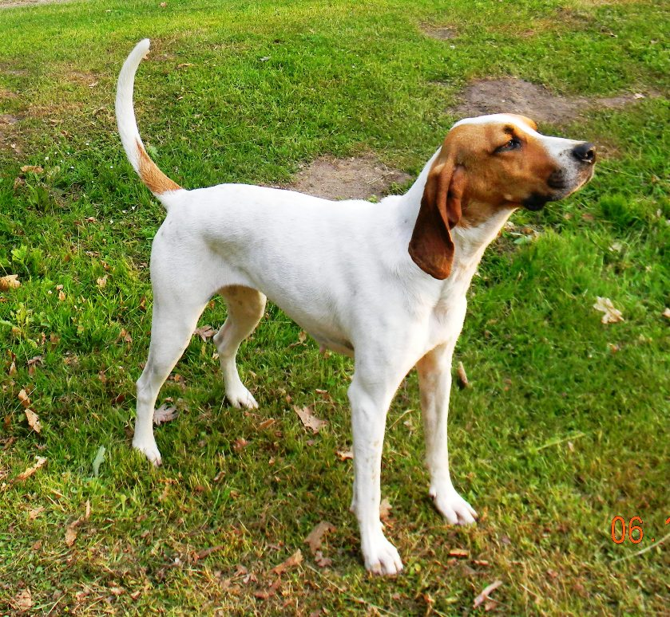

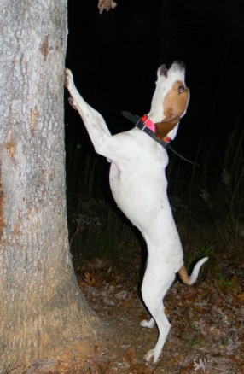

(UKC pedigree listed above)
Kentucky Mtn English Kennel UKC and AKC Litter Registered English Coonhound D.O.B. 3-17-12
Jody and Penny Jessup Vaccinations while at Kentucky English Kennel
Lydia and Christopher Wormed at 3 weeks, 5 weeks, 7 weeks, 9 weeks
8990 Crestbrook Road 1st shot – 5-way with Corona 7 weeks 5-5-12
Rural Hall, NC 27045 2nd shot – 5-way with Corona 9 weeks 5-20-12
859-339-7992 (Penny Cell) 3rd shot –5-way with Corona

-----------------------------------Tracey’s Moonlight BJ
------------------------------NITECH CH ‘PR’ Moonlight Trailer
--------------------------------------------GRCH ‘PR’ Tracey’s Moonlight Penny
------------------ GRCH ‘PR’ Moonlight Drummer
--------------------------------------------‘PR’ Acheson & Burnworth’s Bang
------------------------------CH ‘PR’ Sadis Slammin Coon
--------------------------------------------Wooded Swamp Red
------CH ‘PR’ Moonlight Charlie
-------------------------------------------GRNITECH GRCH ‘PR’ Wilcox’ Thunder Bingo
------------------------------NITECH ‘PR’ Oney’s King
-------------------------------------------‘PR’ Jack’s Thunder Sue
-----------------‘PR’ Spieth’s Big Time Kate
------------------------------------------NITECH ‘PR’ Perk’s Northern Cujo
------------------------------‘PR’ Oney’s Kate
------------------------------------------‘PR’ Weddle’s Judy
CCH GRCH ‘PR’ Kentucky Mtn. Moonlight Diamond DNA-P
------------------------------------------GRNITECH Smith’s Hardtime Rocky
------------------------------GRCH GRNITECH ‘PR’ Oliver’s Hard Time Moses
------------------------------------------‘PR’ Gladyfork Squalling Sue
-----------------NITECH CH ‘PR’ Hard Time Chance
-----------------------------------------GRNITECH ‘PR’ Powers’ Hardtime Red Cloud
------------------------------‘PR’ Power Rock Space Jam
-----------------------------------------NITECH ‘PR’ Power’s Redsky Kayla
------GRCH ‘PR’ Clown Around Patches
---------------------------------------GRNITECH GRCH ‘PR’ Sugar Creek J.R.
------------------------------NITECH Cron’s Bran Bottom Tag
--------------------------------CH Di Bar’s Hardtime Dusty
---------------‘PR’ Johnson’s Lady Rockin Clown
--------------------------------------GRNITECH Smith’s Hardtime Rocky
------------------------------NITECH GRCH ‘PR’ Hardtrockn Clown -----------------------------------------CH ‘PR’ Koly’s Little Lady

